**DIY Knockout**

KnockoutJS provides some nice tutorials to use with your first steps in the world of Knockout.

1. Go the site of Knockout and complete the first two tutorials (Introduction, Working with Lists and Collections)
2. Use your new knowledge to create a dynamic Talent Launch week schedule in your application. You have three drop-down selectors, fields which show your selection and a button to add courses to your schedule. Your result should look something like this:

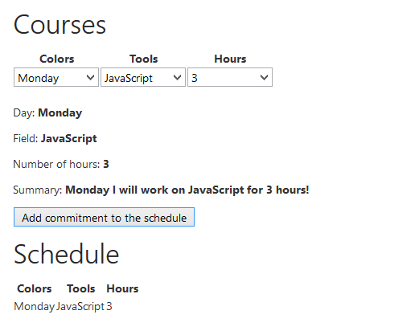

1. When you have time left you can make some improvements.
   * Show summary only when all options have been selected
   * Add a remove button to the schedule